1 . 0VERVIEW OF C :

BASIC STRUCTURE OF C PROGRAMMING:

C program is a collection of several instructions is written as a separate statement . The C program starts with a main function followed by the opening brackets which indicate the start of a function.

C program may contain one or more section as shown below :

DOCUMENTATION SECTION

LINK SECTION

DEFINITION SECTION

GLOBAL DECLARATION SECTION

Main() Function section

{

Declaration part

Executable part

}

SUBPROGRAM SECTION

User defined functions

Objective :

To be familiar with different data types and Expression in C :

Program: Write a program will print my name , department and roll number

Code:

#include<stdio.h>

int main()

{

printf(" my name is: Maimoona Hoque\n") ;

printf("Roll is : BBH 2111032F\n ") ;

printf ("Department : ICE") ;

}

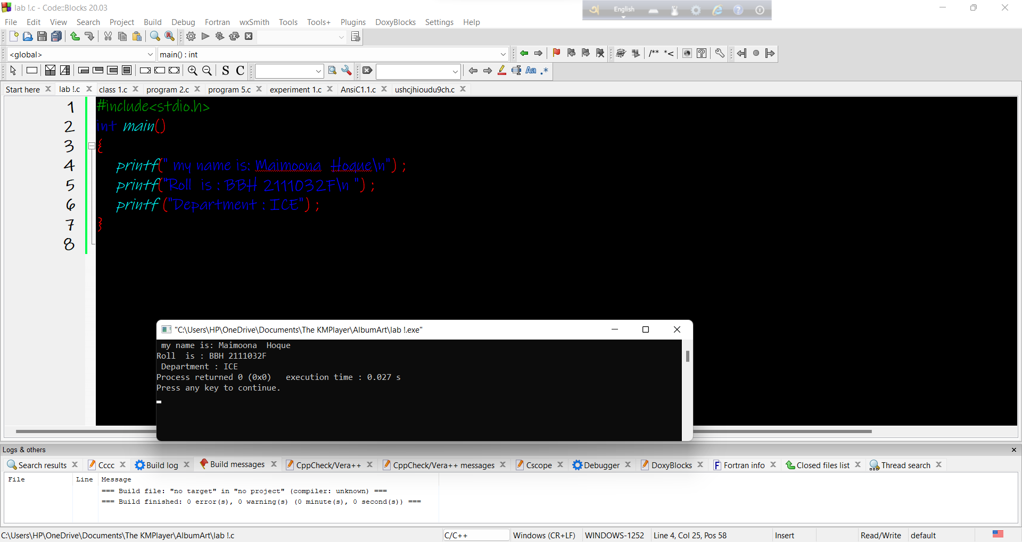

Objectives: To know relationship between Celsius and Fahrenheit

PROGRAM : Form Celsius to Fahrenheit .

Code:

#include<stdio.h>

int main()

{

int Fahrenheit , Celsius , C , F , temp ;

Fahrenheit = F ;

Celsius = C ;

printf("Enter the temperature :") ;

scanf ("%d", &temp ) ;

F = 1.8\* temp +32 ;

printf("The Fahrenheit temparature is =%d\n ", F ) ;

}

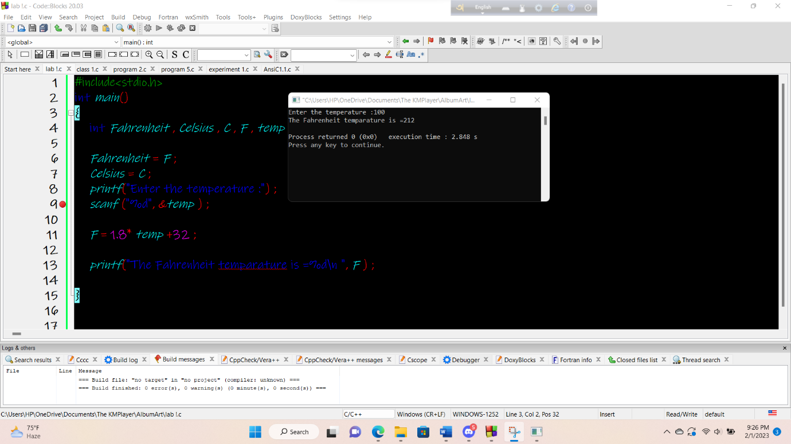

Objectives: To be familiar with the area of triangle .

Program : Area of triangle is given by the formula

A = $√s(s-a)(s-b)(s-c)$

Code:

#include<stdio.h>

#include<math.h>

int main()

{

int a , b , c ;

float s , area ;

a = 30 ;

b= 40 ;

c= 50 ;

s=(a+b+c)/2 ;

area=sqrt (s\*(s-a)\*(s-b)\*(s-c)) ;

printf("the area of triangle is = %.2f\n",area) ;

return 0 ;

}

0utput:

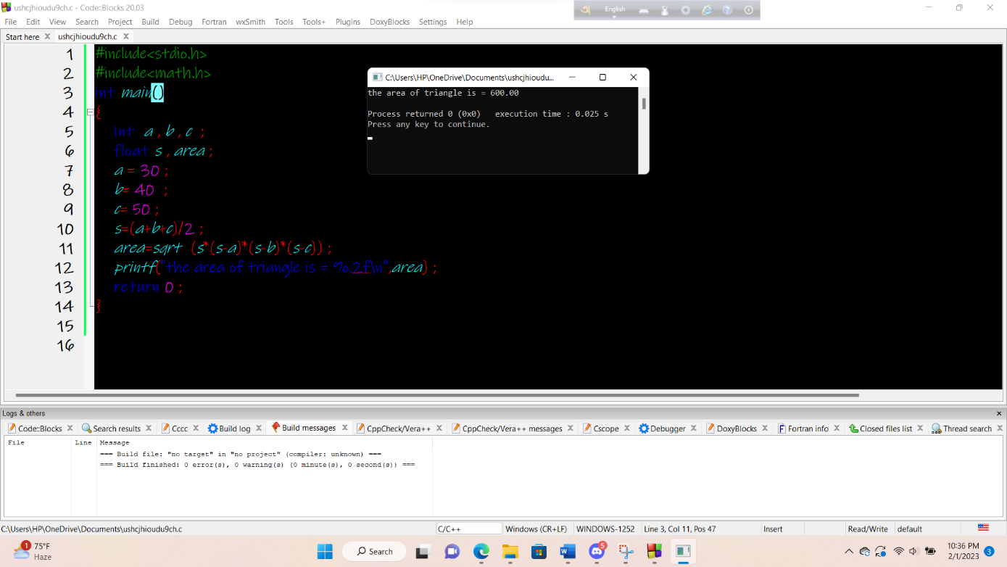

Objective : To know the arithmetic expression in C

Program : Write a program to display the following simple arthmatic calculator Code :

#include<stdio.h>

#include<math.h>

int main()

{

int a , b , sum , difference , product ;

float division ;

a = 30 ;

b= 20 ;

sum = a + b ;

difference = a - b ;

product = a \* b ;

division =a/b ;

printf("Sum = %d\n ", sum ) ;

printf("Difference = %d\n ", difference ) ;

printf("product = %d\n ", product ) ;

printf("Division= %f\n ", division ) ;

}

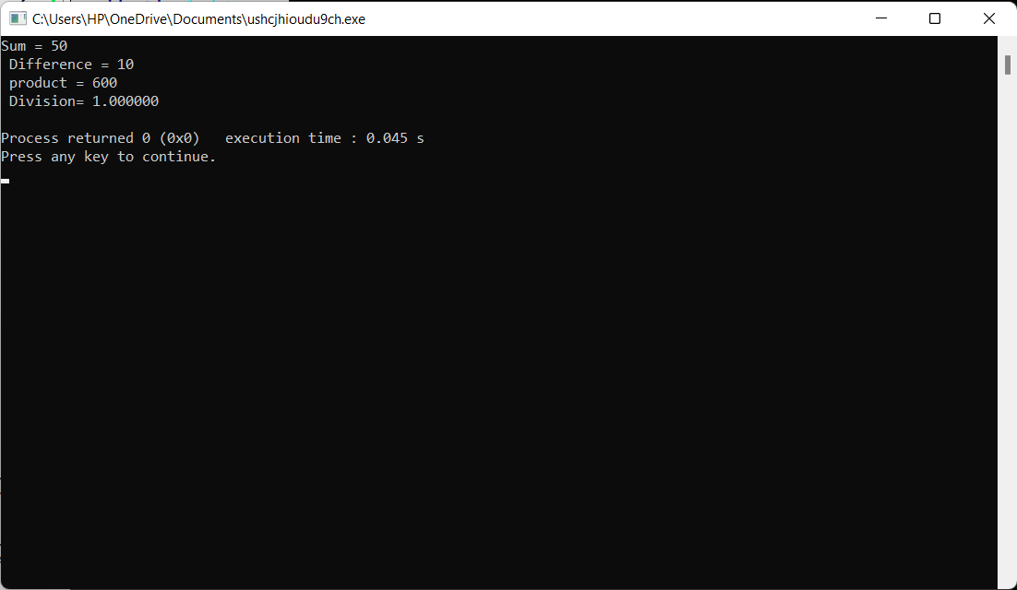

Objective : To know the year of investment .

Program : To know the interest Calculation

Code:

#include<math.h>

int main()

{

int year , period;

float amount , value , inrate ;

amount = 5000;

inrate = 0.11 ;

year = 0 ;

period = 10 ;

while(year<=period)

{

printf("%2d %8.2f\n", year , amount) ;

value = amount + inrate\*amount ;

year = year + 1;

amount = value ;

}

}

Output:

